Unit 3 Performance Assessment 2– IP Telephones

In this lab you will be using Packet Tracer. You will be using your Packet Tracer network from your previous lab. You will need to delete the three switches and replace them with new switches to clear out any previous configuration on the switches.

Your network will a class B network based on a number assigned by your professor, which you will be using for the duration of the class. In the lab anytime you see an underline you should fill in this number.

**Student network: 10.____.0.0/16**

**Using the Packet Tracer network you created in Unit 2, place two IP telephones into the server network and remove the sniffer. Also remove Sw3 and the devices connected to it. Your new network should look like the image below.**

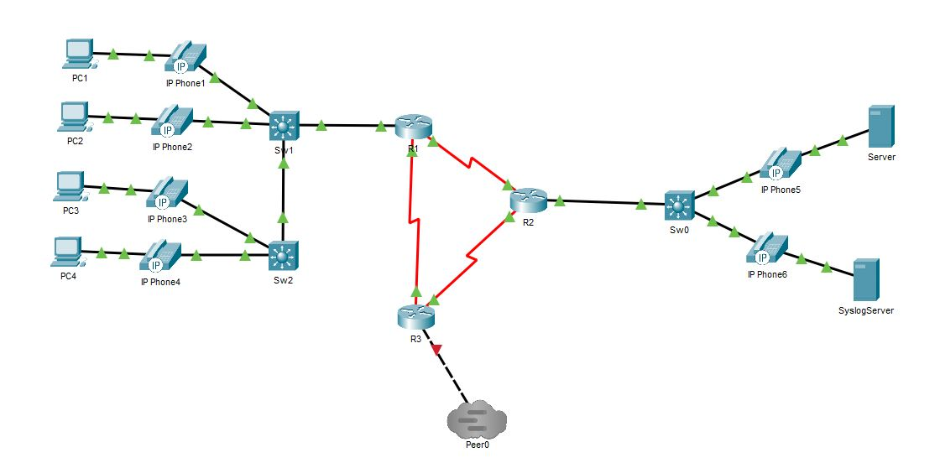

**Task 1 – Configuring the switches**

**Now that you have replaced your switches with new switches, we will configure data and voice VLANs on the same switches. Once again** follow the steps below for all three switches on the left side of your network and the one switch on the right side.

Sw1 (config)# **vlan 10**

Sw1 (config-vlan)# **name data**

Sw1 (config-vlan)# **vlan 20**

Sw1 (config-vlan)# **name voice**

Sw1 (config-vlan)# **exit**

Sw1 (config)# **interface range fa0/1-24**

Sw1 (config-if-range)# **switchport trunk encapsulation dot1q**

Sw1 (config-if-range)# **switchport mode trunk**

Sw1 (config-if-range)# **switchport voice vlan 20**

Sw1 (config-if-range)# **switchport trunk native vlan 10**

Sw1 (config)# **interface range g0/1-2**

Sw1 (config-if-range)# **switchport trunk encapsulation dot1q**

Sw1 (config-if-range)# **switchport mode trunk**

Sw1 (config-if-range)# **switchport voice vlan 20**

Sw1 (config-if-range)# **switchport trunk native vlan 10**

Sw2 (config)# **vlan 10**

Sw2 (config-vlan)# **name data**

Sw2 (config-vlan)# **vlan 20**

Sw2 (config-vlan)# **name voice**

Sw2 (config-vlan)# **exit**

Sw2 (config)# **interface range fa0/1-24**

Sw2 (config-if-range)# **switchport trunk encapsulation dot1q**

Sw2 (config-if-range)# **switchport mode trunk**

Sw2 (config-if-range)# **switchport voice vlan 20**

Sw2 (config-if-range)# **switchport trunk native vlan 10**

Sw2 (config)# **interface range g0/1-2**

Sw2 (config-if-range)# **switchport trunk encapsulation dot1q**

Sw2 (config-if-range)# **switchport mode trunk**

Sw2 (config-if-range)# **switchport voice vlan 20**

Sw2 (config-if-range)# **switchport trunk native vlan 10**

Sw0 (config)# **vlan 10**

Sw0 (config-vlan)# **name data**

Sw0 (config-vlan)# **vlan 20**

Sw0 (config-vlan)# **name voice**

Sw0 (config-vlan)# **exit**

Sw0 (config)# **interface range fa0/1-24**

Sw0 (config-if-range)# **switchport trunk encapsulation dot1q**

Sw0 (config-if-range)# **switchport mode trunk**

Sw0 (config-if-range)# **switchport voice vlan 20**

Sw0 (config-if-range)# **switchport trunk native vlan 10**

Sw0 (config)# **interface range g0/1-2**

Sw0 (config-if-range)# **switchport trunk encapsulation dot1q**

Sw0 (config-if-range)# **switchport mode trunk**

Sw0 (config-if-range)# **switchport voice vlan 20**

Sw0 (config-if-range)# **switchport trunk native vlan 10**

Next reprogram R1 and R2 as follows

R1 (config)# **no interface fa0/0.10**

R1 (config)# **no interface fa0/0.20**

R1 (config)# **interface fa0/0**

R1 (config-if)# **no ip address**

R1 (config)# **interface fa0/0.10**

R1 (config)# **encapsulation dot1q 10 native**

R1 (config-if)# **ip address 10.___.1.1 255.255.255.0**

R1 (config)# **interface fa0/0.20**

R1 (config)# **encapsulation dot1q 20**

R1 (config-if)# **ip address 111.___.1.1 255.255.255.0**

R2 (config)# **interface fa0/0**

R2 (config-if)# **no ip address**

R2 (config)# **interface fa0/0.10**

R2 (config)# **encapsulation dot1q 10 native**

R2 (config-if)# **ip address 10.___.2.1 255.255.255.0**

R2 (config)# **interface fa0/0.20**

R2 (config)# **encapsulation dot1q 20**

R2 (config-if)# **ip address 112.___.1.1 255.255.255.0**

Now we’ll add the DHCP to the R1 router. Verify which DHCP pools you already have on R1 and make sure you remove them before configuring the new ones below. You can remove your previous DCHP pools by going to config mode and *typing no ip dchp pool poolname (where poolname is the name of the pool).*

R1 (config)# **ip dhcp excluded-address 10.___.1.0 10.___.1.19**

R1 (config)# **ip dhcp excluded-address 10.___.2.0 10.___.2.19**

R1 (config)# **ip dhcp excluded-address 111.___.1.0 111.___.1.19**

R1 (config)# **ip dhcp excluded-address 112.___.1.0 112.___.1.19**

R1 (config)# **ip dhcp pool data1**

R1 (dhcp-config)# **network 10.___.1.0 255.255.255.0**

R1 (dhcp-config)# **default-router 10.___.1.1**

R1 (dhcp-config)# **exit**

R1 (config)# **ip dhcp pool data2**

R1 (dhcp-config)# **network 10.___.2.0 255.255.255.0**

R1 (dhcp-config)# **default-router 10.___.2.1**

R1 (dhcp-config)# **exit**

R1 (config)# **ip dhcp pool voice1**

R1 (dhcp-config)# **network 111.___.1.0 255.255.255.0**

R1 (dhcp-config)# **default-router 111.___.1.1**

R1 (dhcp-config)# **option 150 ip 111.___.1.1**

R1 (dhcp-config)# **exit**

R1 (config)# **ip dhcp pool voice2**

R1 (dhcp-config)# **network 112.___.1.0 255.255.255.0**

R1 (dhcp-config)# **default-router 112.___.1.1**

R1 (dhcp-config)# **option 150 ip 112.___.1.1**

R1 (dhcp-config)# **exit**

On your R2 router add the following:

R2 (config)# **interface f0/0.10**

R2 (config-subif)# **ip helper-address 10.___.5.1**

R2 (config-subif)# **interface f0/0.20**

R2 (config-subif)# **ip helper-address 10.___.5.1**

Now we will configure routing using EIGRP. We can keep OSPF on the routers, so no need to remove that configuration. EIGRP has a lower administrative distance than OSPF, so once configured, your routers should use EIGRP to route between the networks.

R1 (config)# **router eigrp 100**

R1 (config-router)# **network 10.0.0.0**

R1 (config-router)# **network 111.0.0.0**

R1 (config-router)# **no auto-summary**

R2 (config)# **router eigrp 100**

R2 (config-router)# **network 10.0.0.0**

R1 (config-router)# **network 112.0.0.0**

R1 (config-router)# **no auto-summary**

R3 (config)# **router eigrp 100**

R3 (config-router)# **network 10.0.0.0**

R3 (config-router)# **network 11.0.0.0**

R3 (config-router)# **no auto-summary**

You can verify EIGRP is working properly now by going to each router and typing a show ip route. You should now see EIGRP learned routes that begin with the letter D (example highlighted below).

*R1#sh ip route*

*10.0.0.0/8 is variably subnetted, 5 subnets, 2 masks*

*C 10.50.1.0/24 is directly connected, FastEthernet0/0.10*

*D 10.50.2.0/24 [90/2172416] via 10.50.5.2, 00:08:09, Serial0/0/0*

*C 10.50.5.0/30 is directly connected, Serial0/0/0*

*D 10.50.5.4/30 [90/2681856] via 10.50.5.2, 00:08:09, Serial0/0/0*

*[90/2681856] via 10.50.5.9, 00:04:31, Serial0/0/1*

*C 10.50.5.8/30 is directly connected, Serial0/0/1*

*111.0.0.0/24 is subnetted, 1 subnets*

*C 111.50.1.0 is directly connected, FastEthernet0/0.20*

*112.0.0.0/24 is subnetted, 1 subnets*

*D 112.50.1.0 [90/2172416] via 10.50.5.2, 00:08:09, Serial0/0/0*

Go to your R1 and R2 routers and program the telephone services

R1 (config)# **telephony-service**

R1 (config-telephony)#**ip source-address 111.___.1.1 port 2000**

R1 (config-telephony)#**max-dn 16**

R1 (config-telephony)#**max-ephones 16**

R1 (config-telephony)#**auto assign 1 to 16**

R1 (config-telephony)#**create cnf-files**

R1 (config-telephony)# **ephone-dn 1**

R1 (config-ephone-dn)# **number ___111**

R1 (config-ephone-dn)# **ephone-dn 2**

R1 (config-ephone-dn)# **number ___112**

R1 (config-telephony)# **ephone-dn 3**

R1 (config-ephone-dn)# **number ___113**

R1 (config-ephone-dn)# **ephone-dn 4**

R1 (config-ephone-dn)# **number ___114**

R1 (config-telephony)# **ephone-dn 5**

R1 (config-ephone-dn)# **number ___115**

R1 (config-ephone-dn)# **ephone-dn 6**

R1 (config-ephone-dn)# **number ___116**

R2 (config)# **telephony-service**

R2 (config-telephony)#**ip source-address 112.___.1.1 port 2000**

R2 (config-telephony)#**max-dn 16**

R2 (config-telephony)#**max-ephones 16**

R2 (config-telephony)#**auto assign 1 to 16**

R2 (config-telephony)#**create cnf-files**

R2 (config-telephony)# **ephone-dn 1**

R2 (config-ephone-dn)# **number ___211**

R2 (config-ephone-dn)# **ephone-dn 2**

R2 (config-ephone-dn)# **number ___212**

You may need to disconnect and reconnect your phones from the network in order for them to pull their telephone number and begin working.

Finally, you are going to program routing between your R1 network and the R2 network. Program into your routers

R1 (config)# **dial-peer voice 1 voip**

R1 (config-telephony)#**session target ipv4:10.___.5.2**

R1 (config-telephony)#**destination-pattern ___21. 🡨 the dot is important**

R2 (config)# **dial-peer voice 1 voip**

R2 (config-telephony)# **session target ipv4:10.___.5.1**

R2 (config-telephony)# **destination-pattern ___11. 🡨 the dot is important**

Now the fun part- you will place a call between IP phone1 and IP phone6. You can see the phone number assigned to a phone by clicking on the phone, and udder GUI you will see its number on the phone’s screen in the top right corner. Now all you need to do is dial the number of the phone you want to call, and then click on the red area on the phone you are calling from- this makes the call. Then on the phone you are calling you should hear a ring, and once again click on the red area to pick up. It now should say Connected on the screens of both phones- you just made a call from an IP phone on one network to an IP phone on another network.

Take a screenshot of the completed call. It should look something like this.

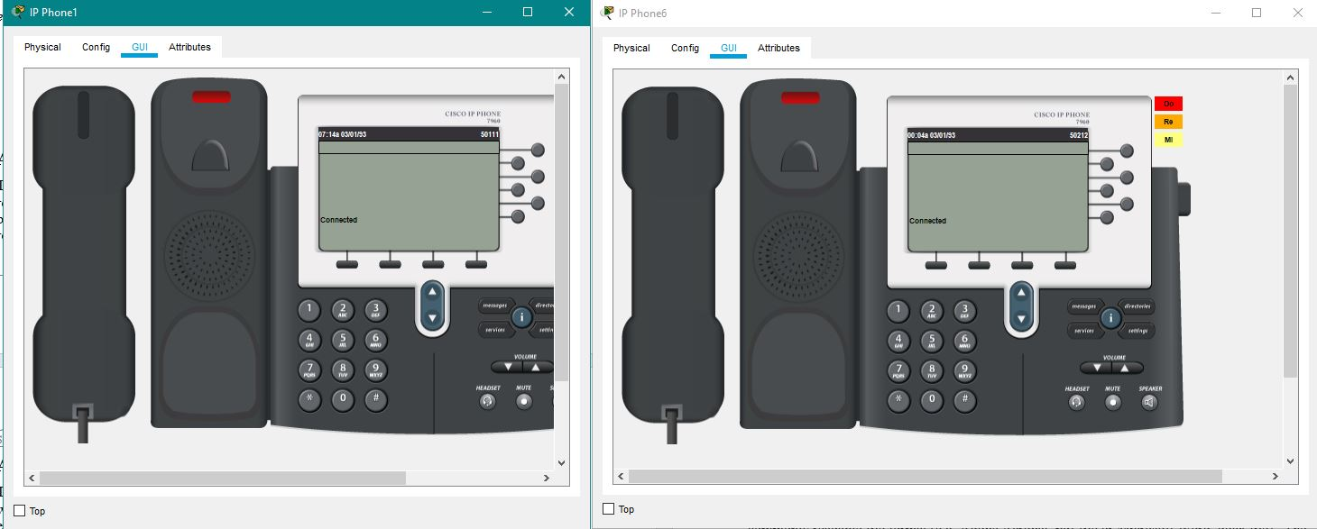

**Deliverables**

* Screenshot of working network
* Screenshot of a show ip route from each router
* Screenshot of a completed call from IP phone1 to IP phone6

PASTE SCREENSHOTS BELOW

**Task 2 – Adding a phone to Tier 1**

Now you are going to add a telephone to the Tier 1 network and place a call between the two networks. Open you Tier 1 network and add the following to the network.

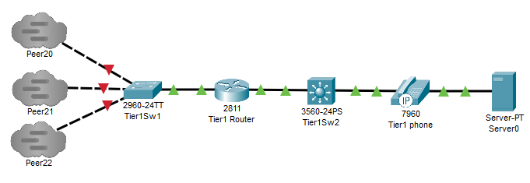

Replace your 1841 router with a 2811 router and program the networks to be

|  |  |  |  |  |
| --- | --- | --- | --- | --- |
| **System** | **Port** | **Connect To** | **IP address** | **Subnet Mask** |
| Tier1 | F0/0 | Sw1 | 11.0.0.1 | 255.255.255.0 |
|  | F0/1.10 | Data | 11.1.1.1 | 255.255.255.0 |
|  | F0/1.20 | Voice | 113.___.1.1 | 255.255.255.0 |

Program the new Tier1Sw2 switch as follows

Tier1Sw2 (config)# **vlan 10**

Tier1Sw2 (config-vlan)# **name data**

Tier1Sw2 (config-vlan)# **vlan 20**

Tier1Sw2 (config-vlan)# **name voice**

Tier1Sw2 (config-vlan)# **exit**

Tier1Sw2 (config)# **interface range fa0/1-24**

Tier1Sw2 (config-if-range)# **switchport trunk encapsulation dot1q**

Tier1Sw2 (config-if-range)# **switchport mode trunk**

Tier1Sw2 (config-if-range)# **switchport voice vlan 20**

Tier1Sw2 (config-if-range)# **switchport trunk native vlan 10**

Tier1Sw2 (config)# **interface range g0/1-2**

Tier1Sw2 (config-if-range)# **switchport trunk encapsulation dot1q**

Tier1Sw2 (config-if-range)# **switchport mode trunk**

Tier1Sw2 (config-if-range)# **switchport voice vlan 20**

Tier1Sw2 (config-if-range)# **switchport trunk native vlan 10**

**Program the Tier1Router as follows**

Tier1Router(config)# **interface f0/0**

Tier1Router(config-if)# **ip address 11.0.0.1 255.255.255.0**

Tier1Router(config-if)# **no shutdown**

Tier1Router(config-if)# **interface f0/1**

Tier1Router(config-if)# **no shutdown**

Tier1Router(config-if)# **interface f0/1.10**

Tier1Router(config-subif)# **encapsulation dot1q 10**

Tier1Router(config-subif)# **ip address 11.1.1.1 255.255.255.0**

Tier1Router(config-subif)# **interface f0/1.20**

Tier1Router(config-subif)# **encapsulation dot1q 20**

Tier1Router(config-subif)# **ip add 113.___.1.1 255.255.255.0**

Tier1Router (config)# **ip dhcp excluded-address 113.___.1.0 113.___.1.19**

Tier1Router (config)# **ip dhcp pool voice1**

Tier1Router (dhcp-config)# **network 113.___.1.0 255.255.255.0**

Tier1Router (dhcp-config)# **default-router 113.___.1.1**

Tier1Router (dhcp-config)# **option 150 ip 113.___.1.1**

Tier1Router (config)# **telephony-service**

Tier1Router (config-telephony)#**ip source-address 113.___.1.1 port 2000**

Tier1Router (config-telephony)#**max-dn 16**

Tier1Router (config-telephony)#**max-ephones 16**

Tier1Router (config-telephony)#**auto assign 1 to 16**

Tier1Router (config-telephony)#**create cnf-files**

Tier1Router (config-telephony)# **ephone-dn 1**

Tier1Router (config-ephone-dn)# **number ___311**

Tier1Router (config-ephone-dn)# **ephone-dn 2**

Tier1Router (config-ephone-dn)# **number ___312**

Tier1Router (config)# **dial-peer voice 1 voip**

Tier1Router (config-telephony)#**session target ipv4:10.___.5.1**

Tier1Router (config-telephony)#**destination-pattern ___11.**

Tier1Router (config)# **dial-peer voice 2 voip**

Tier1Router (config-telephony)# **session target ipv4:10.___.5.2**

Tier1Router (config-telephony)# **destination-pattern ___21.**

**Now program EIGRP on the Teir1Router**

Tier1Router (config)# **router eigrp 100**

Tier1Router (config-router)# **network 11.0.0.0**

Tier1Router (config-router)# **network 113.0.0.0**

Tier1Router (config-router)# **no auto-summary**

**You will now connect the two networks using Multiuser Connection as we have in previous labs.**

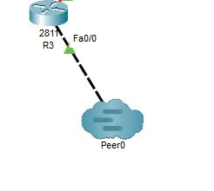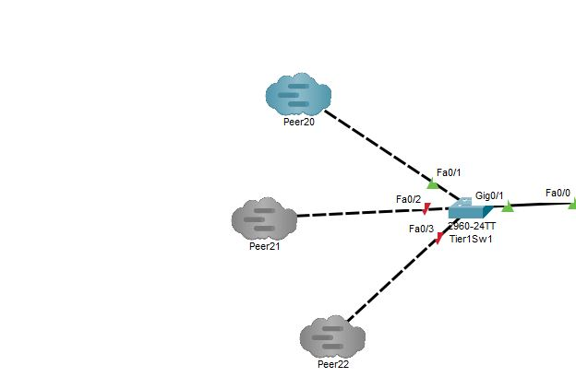

**Go back to R1 and R2 and add**

R1 (config)# **dial-peer voice 2 voip**

R1 (config-telephony)#**session target ipv4:11.0.0.1**

R1 (config-telephony)#**destination-pattern ___31. 🡨 the dot is important**

R2 (config)# **dial-peer voice 2 voip**

R2 (config-telephony)# **session target ipv4:11.0.0.1**

R2 (config-telephony)# **destination-pattern ___31. 🡨 the dot is important**

Place a call from a phone on the R1 network to the Tier1 phone. Then a call from a phone the R2 network to the Tier1 phone. Finally, from the Tier1 phone call a phone on the R2 network. Take three screenshots like the one below.

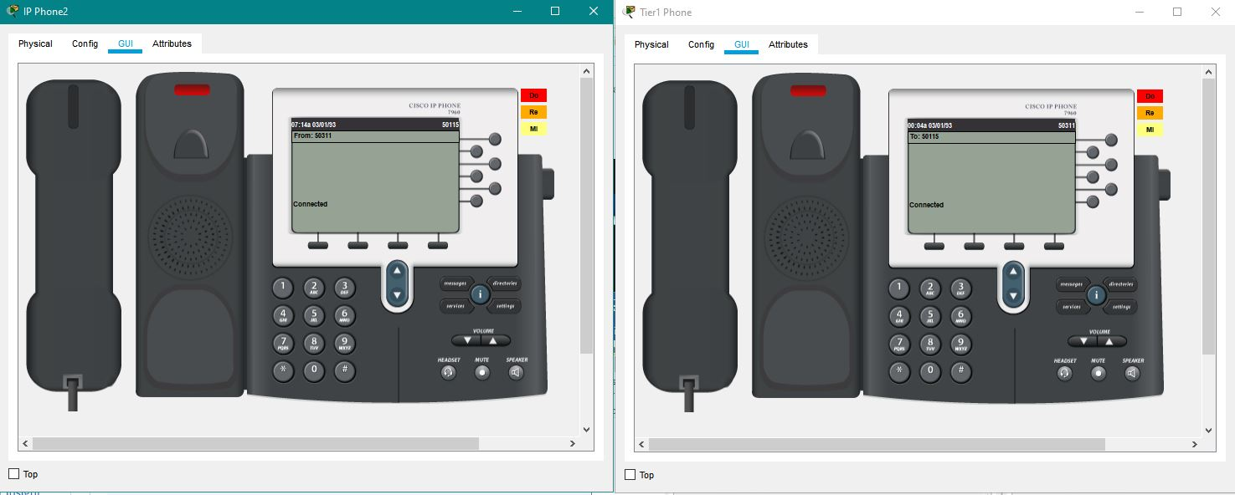

**Deliverables**

* Screenshot of your working Tier 1 network
* Screenshot for call from R1 phone to Tier1 phone
* Screenshot of call from R2 phone to Tier1 phone
* Screenshot of call from Tier1 phone to R2 network phone

PASTE SCREENSHOTS BELOW